|  |  |  |  |  |  |  |  |  |  |  |  |  |  |  |  |
| --- | --- | --- | --- | --- | --- | --- | --- | --- | --- | --- | --- | --- | --- | --- | --- |
| |  |  | | --- | --- | | **NGUYEN VIET XUAN PRIMARY SCHOOL NAME:………………………………………**  **CLASS:………………………..…………….** | **BÀI KIỂM TRA HỌC KÌ I**  **MÔN: TIẾNG ANH - LỚP 3**  **NĂM HỌC 2019 – 2020**  **Thời gian làm bài: 40 phút.** | | | | | | | | | | | | | |  |
| ***Marks*** | ***Listening*** | | | | ***Reading and Writing*** | | | | ***Speaking*** | ***Total*** |
|  | ***Q.1*** | ***Q.2*** | ***Q.3*** | ***Q.4*** | ***Q.1*** | ***Q.2*** | ***Q.3*** | **Q.4** |  |  |
|  |  |  |  |  |  |  |  |

**PART I. LISTENING (4 Marks).**

**Question 1: Listen and number. There is one example. (1 mark)**

|  |  |  |  |  |
| --- | --- | --- | --- | --- |
| **http://www.bradfitzpatrick.com/store/images/products/st007-cartoon-robot-clip-art.jpg** | **http://www.picturesof.net/_images_300/A_Pencil_Case_Royalty_Free_Clipart_Picture_100628-114884-664009.jpg** |  |  |  |

|  |  |  |  |  |
| --- | --- | --- | --- | --- |
|  |  |  |  |  |
| 0 |  |  |  |  |
| **A**. | **B**. | **C**. | **D**. | **E**. |

**Question 2. Listen and draw the line. There is one example. (1 mark)**

|  |  |  |  |  |
| --- | --- | --- | --- | --- |
|  |  |  |  |  |

|  |  |  |  |  |
| --- | --- | --- | --- | --- |
| **A** | **B** | **C** | **D** | **E** |
|  |  |  |  |  |

**O-B 1- ……. 2-……. 3-……. 4-……..**

**Question 3: Listen and tick (🗸).There is one example (1 mark).**

|  |  |
| --- | --- |
| 1.  A. | **B.**  ***🗸*** |
| **2. A.** | **B.** |
| **3. A.** | **B.** |
| **4.A.** | **B.** |
| **5.A.** | **B.** |

**Question 4: Listen and complete. There is one example (1 mark).**

1. Miss Hien : How old are you ?

Phong: I’m (**0**) ten years old.

1. Miss Hien :How old are you ?

Girl: I’m (**1**) \_\_\_\_\_\_\_\_\_\_\_ years old.

1. Miss Hien :How old are you ?

Boy: I’m (**2**) \_\_\_\_\_\_\_\_\_\_\_ years old.

1. MrLoc:How old are you ?

Girl: I’m (**3**) \_\_\_\_\_\_\_\_\_\_\_ years old.

1. MrLoc:How old are you ?

Boy: I’m (**4**) \_\_\_\_\_\_\_\_\_\_\_ years old.

**PART II.READING (2 marks).**

**Question 5: Look and read. Put a tick (V) or a cross (X) in the box.**

**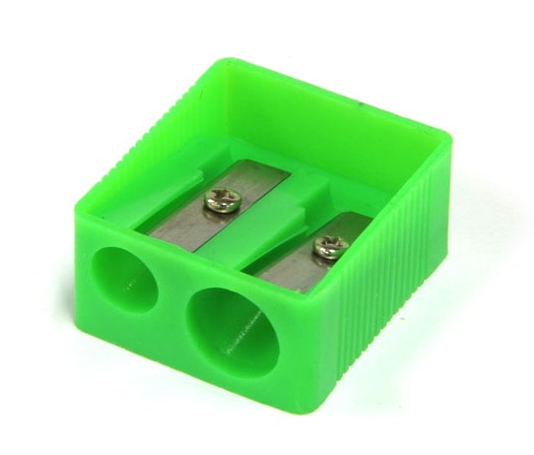There are two examples. (1 mark)**

|  |  |
| --- | --- |
| http://icons.iconarchive.com/icons/mcdo-design/book/512/Note-Book-icon.png  **V**  ***0.***This is a notebook. | X  ***00***.That is a pencil case.  images5 |
| *images*  **1**.Stand up. | **2**.This is my computer room.  images |
| http://www.logo-it.net/r12sb.jpg  **3**. These are rulers. | **4** .This is a classroom . |

**Question 6: Look and read.Write Yes or No . There are two examples. (1 mark)**

|  |  |
| --- | --- |
| Description: MCj02919300000[1]   1. This is a desk. **Yes** | http://www.picturesof.net/_images_300/A_Pencil_Case_Royalty_Free_Clipart_Picture_100628-114884-664009.jpg   1. That’s a pencil sharpener. **No** |
| 1. That is the playground. \_\_\_\_\_\_\_\_ | **2**. This is a library. \_\_\_\_\_\_\_\_\_\_ |
| **3**.These are school bags. \_\_\_\_\_\_\_\_ | D:\LeLy\FILE AT CAC LOP\DKTDK ca nam\anh SGK2013\anh lop 3 moi\P1030920.JPG  **4**. They like football. \_\_\_\_\_\_\_\_\_ |

**PART III.WRITING (2 marks).**

**Question 7: Look at the pictures and the letters.Write the words. There is one example (1 mark)**

|  |  |  |  |
| --- | --- | --- | --- |
| ***Example:*** | ***0***. urrle | | D:\LeLy\FILE AT CAC LOP\DKTDK ca nam\anh SGK2013\anh lop 3 moi\P1030921.JPG**r ul er** |
| **1**. h i t s - - - - | | **2**. sipkipng- - - - - - - - | |
| **3**.scehs - - - - - | | **4.** tondabnim - - - - - - - - - | |

**Question 8: Look and read. Choose the words to fill the blanks .There is one example**

**(1 mark)**

|  |  |  |  |  |
| --- | --- | --- | --- | --- |
| http://t1.gstatic.com/images?q=tbn:ANd9GcS5OddFH3i3NpMekYu7D7I-FL7bmC8yGYlRGNBXL6fh6xjJeGUUbOGH0Q |  |  | **C:\Users\Luyen\Downloads\Screenshot_20181130-093327_Gallery.jpg** |  |
| *school* | *playground* | *Nam* | *Ê đê* | *blind man’s bluff* |

Hello. My name is (**0**)***Nam***. I am a pupil at Nguyen Du Primary school. This is my (**1**) \_\_\_\_\_\_\_\_\_\_\_\_. It is new and nice.The(**2**) \_\_\_\_\_\_\_\_\_\_\_ is very large. I play and chat with my friends there. And that is my new friend. She is H’Loan. She is

(**3**) \_\_\_\_\_\_\_\_\_\_\_. She lives in Buon Ho Town. At break time, I and H’Loan like

(**4**) \_\_\_\_\_\_\_\_\_\_\_\_\_\_\_\_ very much.

**PART IV: SPEAKING (2 marks )( 5 minutes)**

Part 1: Getting to know each other.

Part 2: Talking about school things and activities at break time .

Part 3: Describing the picture.

**THE END**

**Good luck to you!**